

User Guide

User Identity Management

Fundamental – Spring Semester 2018

Sandeep Shivajirao

July 2018

**Java Project with Derby DB**

* 1. **Purpose of this document**

This documents provide a overview of all the step by step user guide aspects to use this Tool.

* 1. **Use of this document**

This document can be used by users to understand and work on this application.

* 1. **Overview**

The document helps in understanding the functionality of the application and how to proceed further to perform specific activities.

**0.4 Requirements:**

Eclipse - Oxygen.3a Release (4.7.3a)

Derby DB – 10.14.2.0

Java SE Development Kit 8

Java SE Runtime Environment

**Logon Screen**

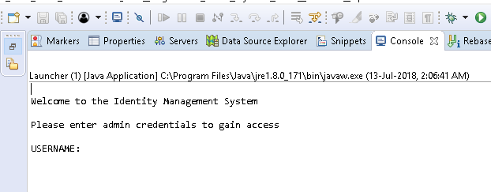

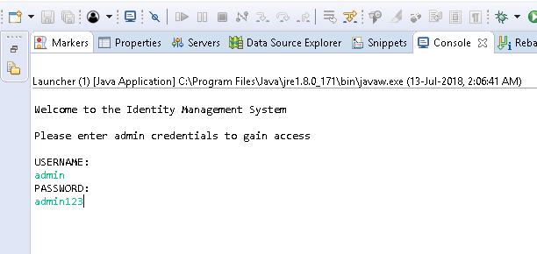

The user name and password need to be entered once requested.

**Initial Screen after logon:**

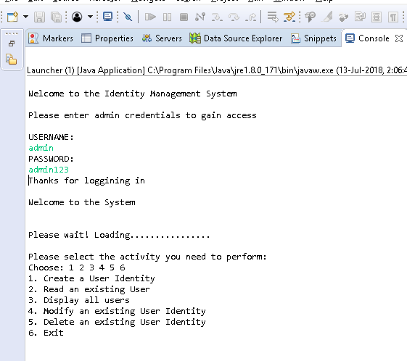

The user will be able to see the menu options available in the application.

1. **Create User in the table**

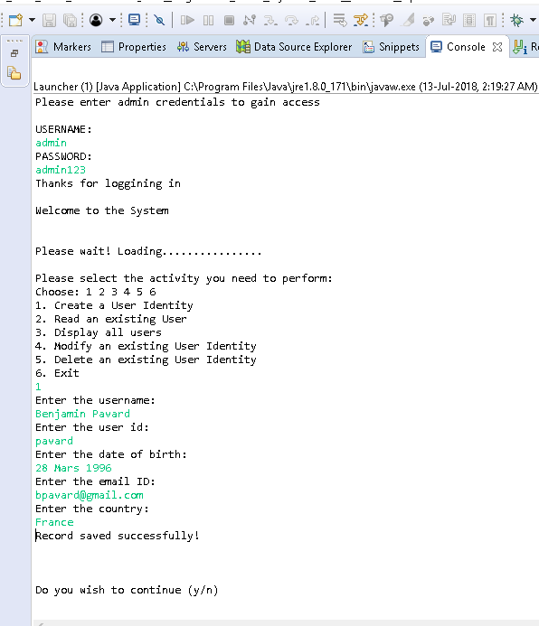

**2. Read exiting user from Table**

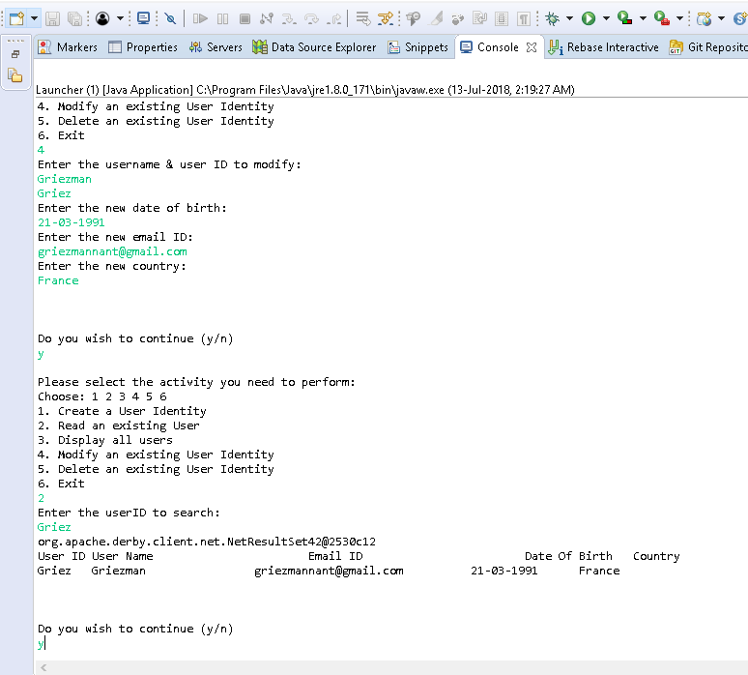

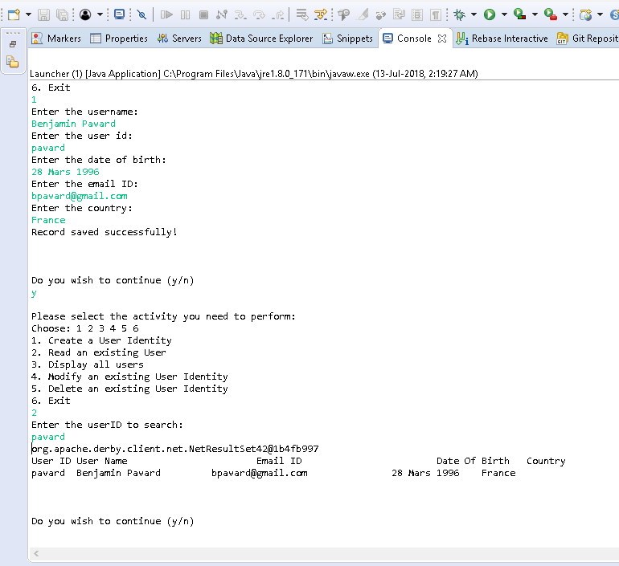

**Incorrect User ID provided to search…….**

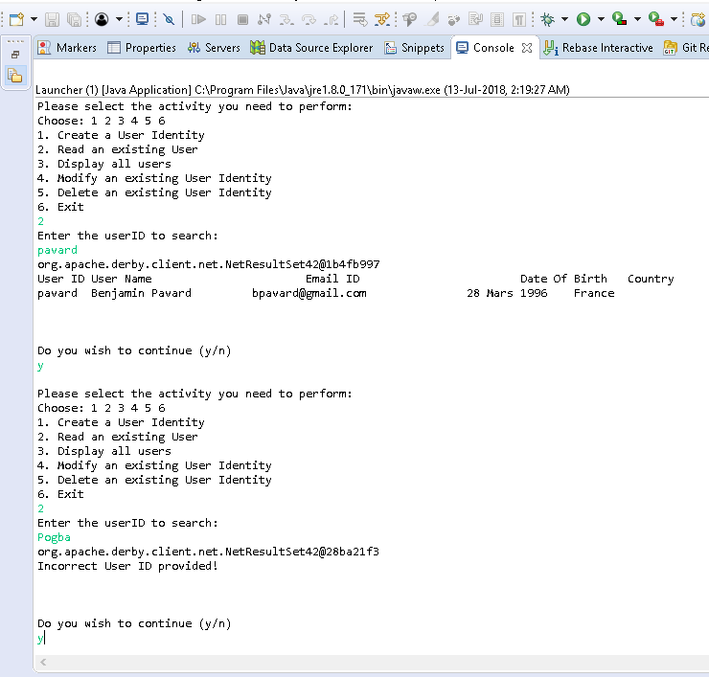

**3. Read all User Ids in Database:**

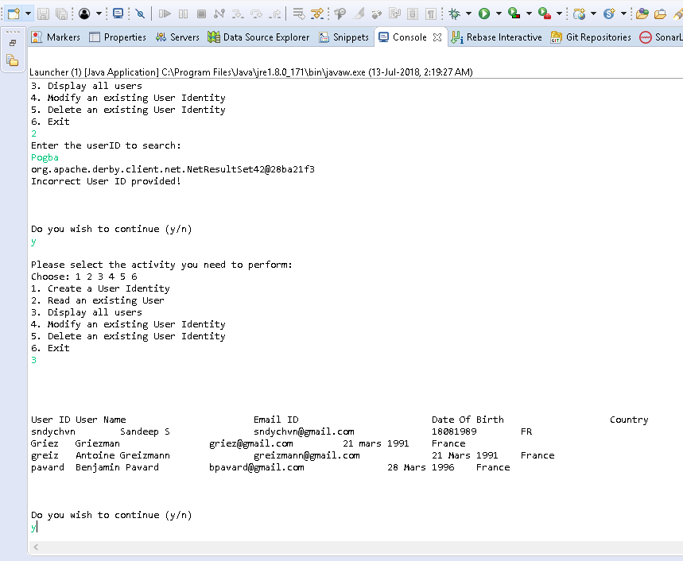

**4. Modify User ID**

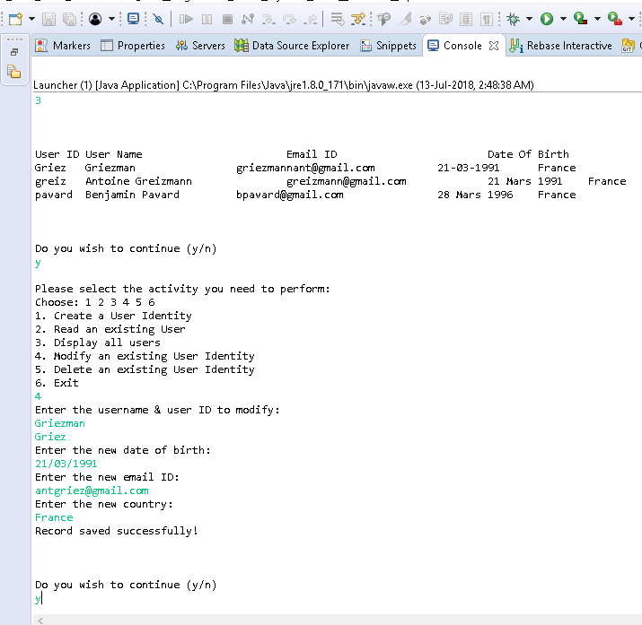

**5. Delete Record from Table**

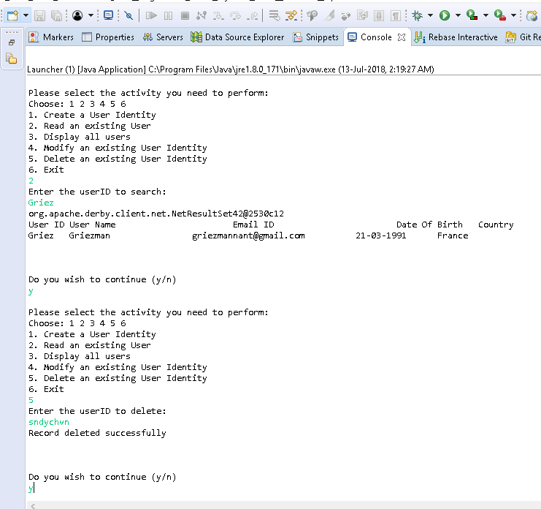

**Incorrect user ID to delete**

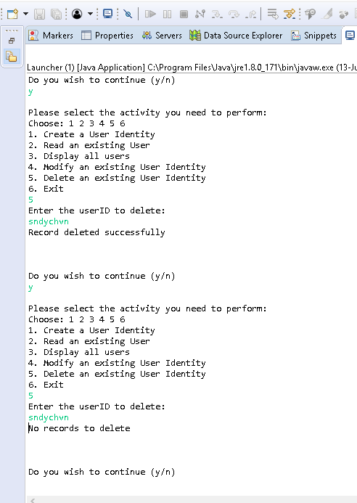

**Do not wish to continue…….**

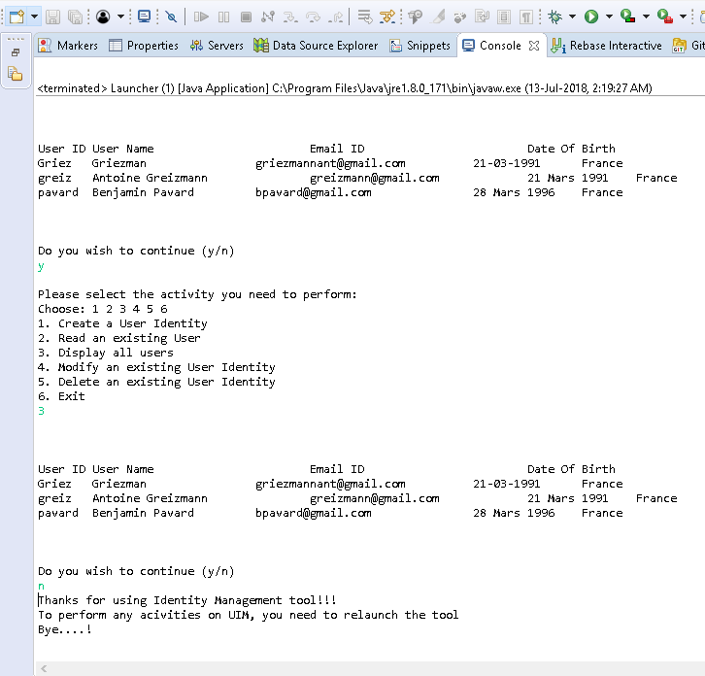

**6. Exit option**

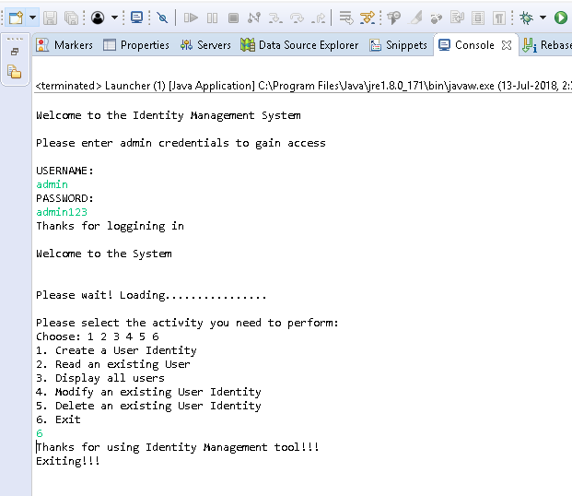

**User does not have access**

